**Pulse generation at different ports of PIC18F4520**

**Project description:**

In this project we have generated the differnet pulse trains of different duty cycles on PA3 and PC3. Circuit diagram of PIC microcontroller with external cystal of 10Mhz is shown. A resistor and pushbutton is also attached.

**Circuit Diagram:**

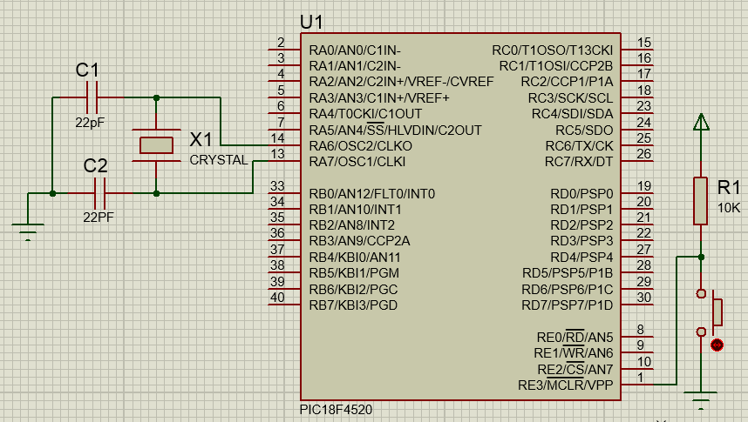

**Question No 1 :**

**Part A:**

**For TH= TL=0.1ms**

**Part of Code which is edited:**

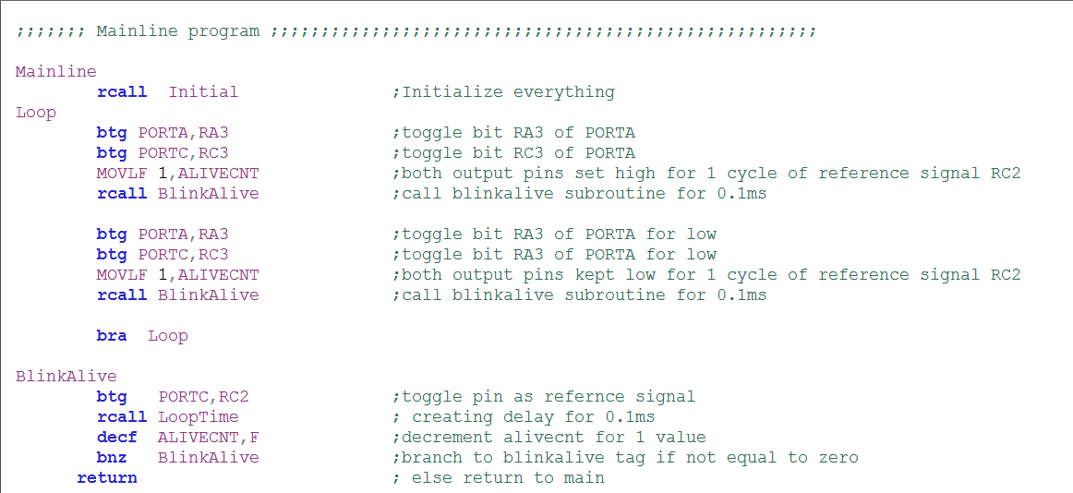

**Flow Chart:**

**Rcall Initial**

Start Loop

Rcall Blinlalive for 0.1ms delay wrt RC2

Load Alivecnt with 1

Toggle RA3&RC3

BRA Loop

Rcall Blinlalive for 0.1ms delay wrt RC2

Load Alivecnt with 1

Toggle RA3&RC3

**wave generation method:**

When the loop starts both the output pins are toggled and in alivecnt variable 1 is kept to set the delay of 0.1ms wrt to the RC2 reference signal.After that blinkalive function is called where refernce signal RC2 is toggled and it this subroutine finished after 0.1ms.After that the RC3 and RA3 are again toggled for 0.1ms by keeping 1 in alivecnt and by recalling blinkalive.To create the pulse train whole process is enclosed in infinte loop to show us the pulse train.

**Waveforms for 50% duty cycle(Th=TL=0.1ms):**

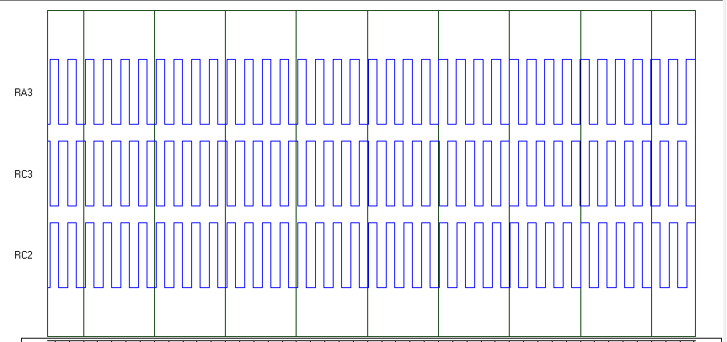

The on time(Th) and off time(TL) are same for RA3 and RC3 as 0.1ms with respect to the refernce signal RC2 .Reference signal is toggling after 0.1ms and both output waveforms are following it.These all waves are of 50% duty cycle because the on time and off time for both waves is the same.

**Part B:**

**For TH= 0.1ms and TL=0.4ms**

**Part of code which is edited :**

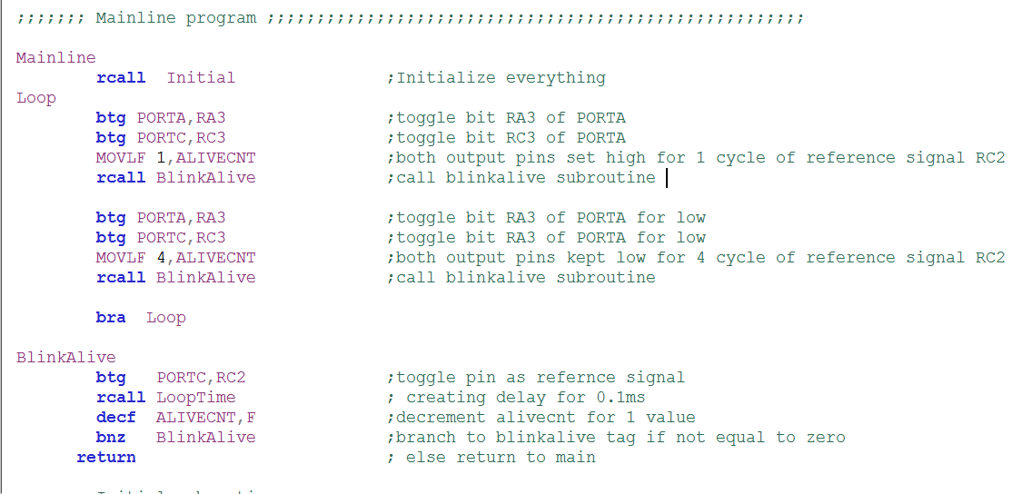

**Flow Chart:**

**Rcall Initial**

Start Loop

Rcall Blinlalive for 0.1ms delay wrt RC2

Load Alivecnt with 1

Toggle RA3&RC3

BRA Loop

Rcall Blinlalive for 0.4ms delay wrt RC2

Load Alivecnt with 4

Toggle RA3&RC3

**Wave generation method:**

When the loop starts both the output pins are toggled and in alivecnt variable 1 is kept to set the delay of 0.1ms wrt to the RC2 reference signal .This will keep the waveform high for 0.1ms .After that blinkalive function is called where refernce signal RC2 is toggled and it this subroutine finished after 0.1ms.After that the RC3 and RA3 are again toggled for 0.4ms by keeping 4 in alivecnt and by recalling blinkalive.To create the pulse train whole process is enclosed in infinte loop to show us the pulse train.

**Waveforms for (Th=0.1ms and TL=0.4ms)**

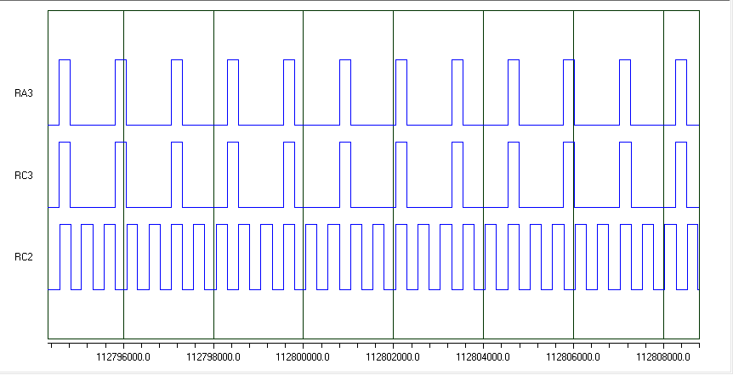

The on time(Th) and off time(TL) are not same for RA3 and RC3 with respect to the refernce signal RC2 .Reference signal is toggling after 0.1ms but in both output waveforms the TH is less as compared to TL. TH is for 0.1ms and TL is for 0.4ms.Although the duty cycle for refernce signal is 50% but the duty cycle for other waveforms is less than 50%.

**Question No 2 :**

**Part A:**

**For TH= TL=0.3ms**

**Part of code which is edited :**

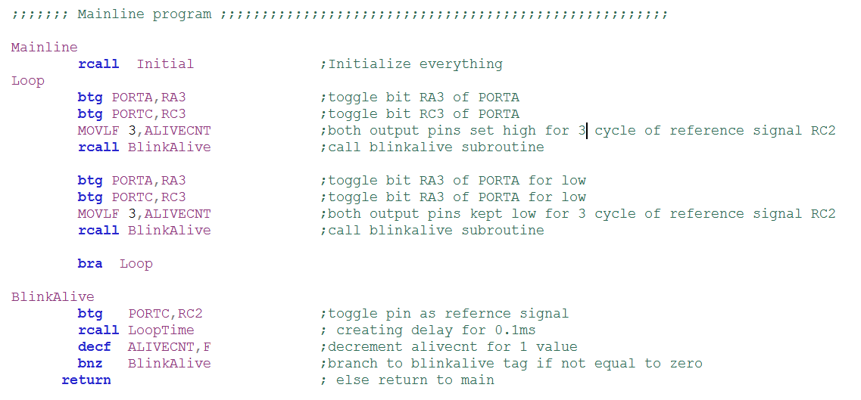

**Flow Chart:**

**Rcall Initial**

Start Loop

Rcall Blinlalive for 0.3ms delay wrt RC2

Load Alivecnt with 3

Toggle RA3&RC3

BRA Loop

Rcall Blinlalive for 0.3ms delay wrt RC2

Load Alivecnt with 3

Toggle RA3&RC3

**Wave generation method:**

When the loop starts both the output pins are toggled and in alivecnt variable 3 is kept to set the delay of 0.3ms wrt to the RC2 reference signal .This will keep the waveform high for 0.3ms .After that blinkalive function is called where refernce signal RC2 is toggled and it this subroutine finished .After that the RC3 and RA3 are again toggled for 0.3ms by keeping 3 in alivecnt and by recalling blinkalive.To create the pulse train whole process is enclosed in infinte loop to show us the pulse train.

**Waveforms for 50% duty cycle(Th=TL=0.3ms):**

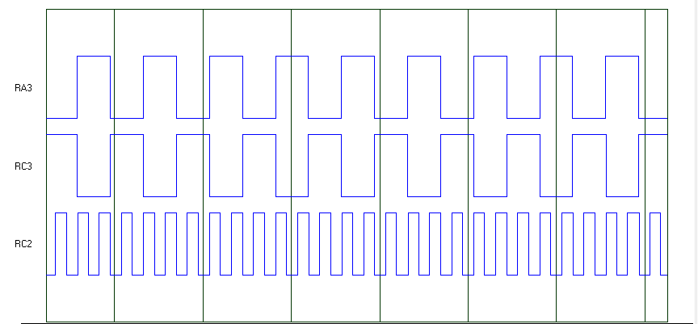

The on time(Th) and off time(TL) are same for RA3 and RC3 as 0.3ms with respect to the refernce signal RC2 .Reference signal is toggling after 0.1ms and both output waveforms are following it.These all waves are of 50% duty cycle because the on time and off time for both waves is the same.

**Part B:**

**For TH= 0.3ms and TL=0.5ms**

**Part of code which is edited :**

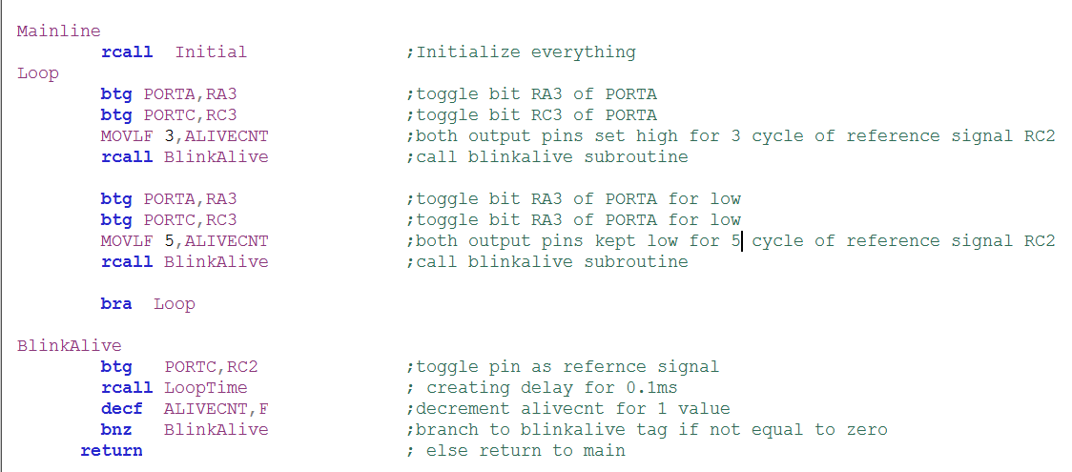

**Flow Chart:**

**Rcall Initial**

Start Loop

Rcall Blinlalive for 0.3ms delay wrt RC2

Load Alivecnt with 3

Toggle RA3&RC3

BRA Loop

Rcall Blinlalive for 0.5ms delay wrt RC2

Load Alivecnt with 5

Toggle RA3&RC3

**Wave generation method:**

When the loop starts both the output pins are toggled and in alivecnt variable 3 is kept to set the delay of 0.3ms wrt to the RC2 reference signal .This will keep the waveform high for 0.3ms .After that blinkalive function is called where refernce signal RC2 is toggled and it this subroutine finished .After that the RC3 and RA3 are again toggled for 0.5ms by keeping 5 in alivecnt and by recalling blinkalive.To create the pulse train whole process is enclosed in infinte loop to show us the pulse train.

**Waveforms for (Th=0.3ms and TL=0.5ms)**

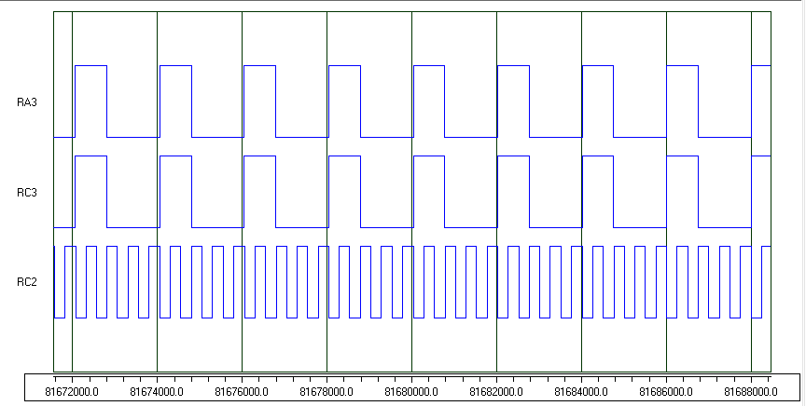

The on time(Th) and off time(TL) are not same for RA3 and RC3 with respect to the refernce signal RC2 .Reference signal is toggling after 0.1ms but in both output waveforms the TH is less as compared to TL. TH is for 0.3ms and TL is for 0.5ms.Although the duty cycle for refernce signal is 50% but the duty cycle for other waveforms is less than 50%.